ASSIGNMENT-1 Warm –up with python

ANS:-1 py –v #version of python

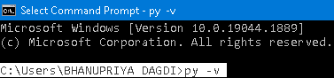

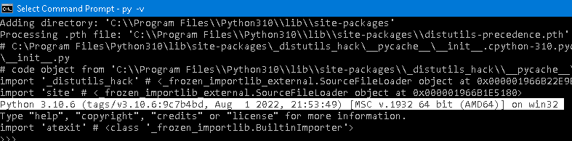

ANS:-2

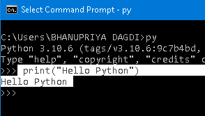

ANS:-3 :-Create a python file on CMD prompt

Using **mkdir**, create a folder **Python** > First.py

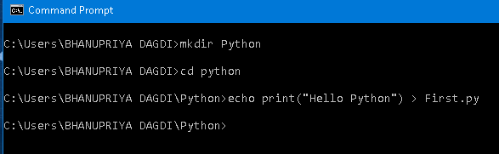

:-Execute a python file on CMD prompt

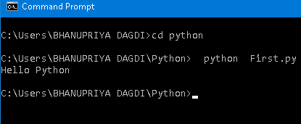

ANS:-4

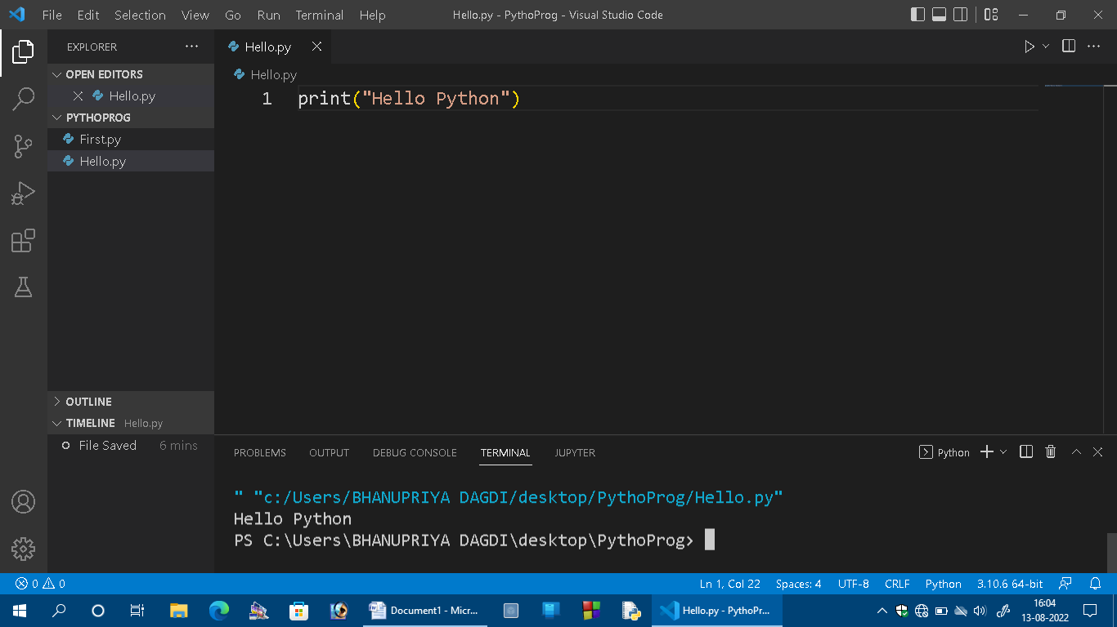

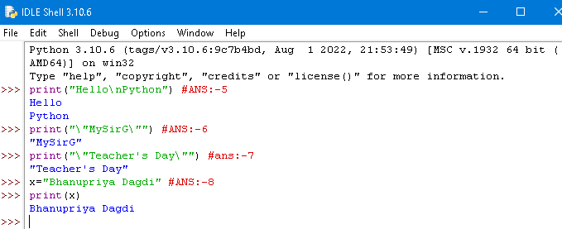

ANS:-9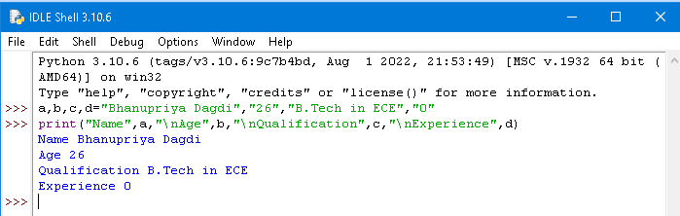ANS:-10